**Javascript**

**Introduction to Javascript**

Javascript is one the basic web programming which is used to handle the data and information

Javascript is can be enclosed with <script></script>

<script> can be placed in either Head and body part of Html document

You can use any number of script tags in single HTML document

If you want to have dynamic activity or runtime activity we have use either javascript or javascript related frameworks(jQuery,ReactJS)

**Event and EventHandler**

Event is runtime activity generated by the end user

For each event performing the specific execution of the program then it comes as EventHandler

**Basic Javascript Example:**

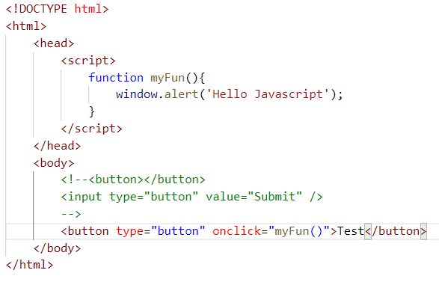

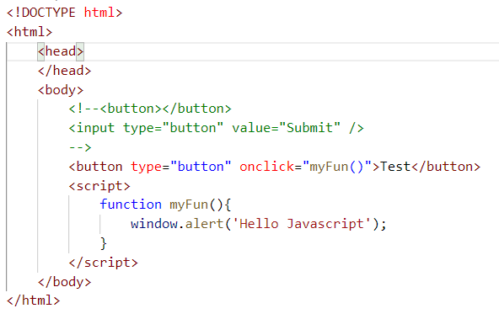

**Multiple Javascript files are linking to Single HTML DOC**

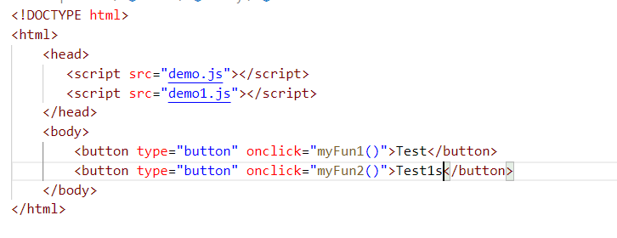

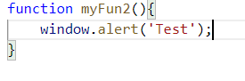

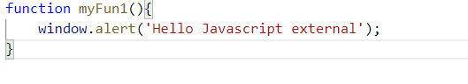

**Javascript Display:**

1. window.alert()
2. document.write()
3. console.log()
4. innerHTML

**Window.alert()**

All the previous will be considered the examples for window alert

**document.write()**

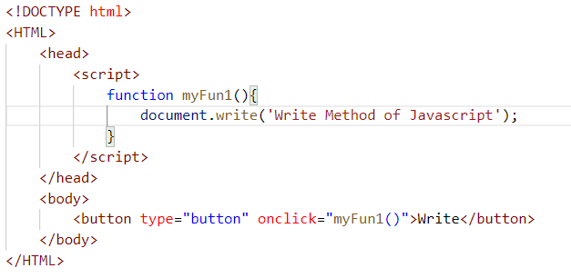

**Console.log()**

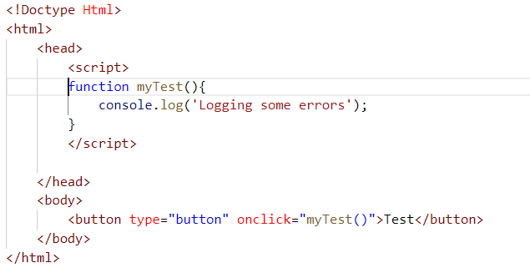

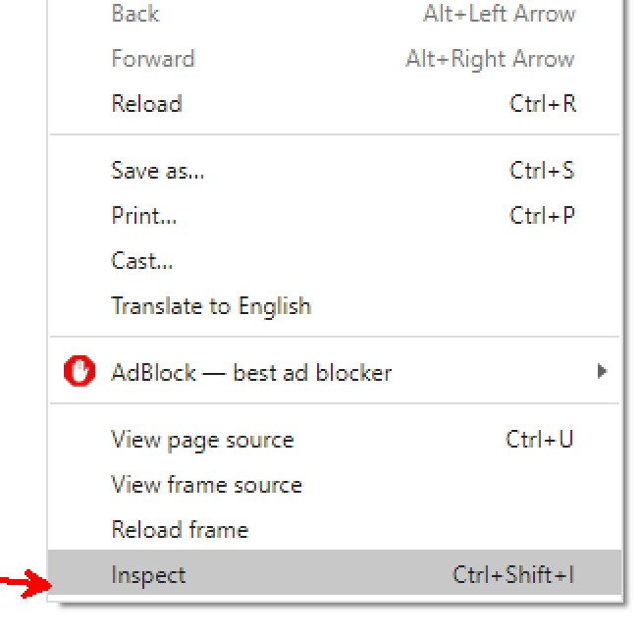

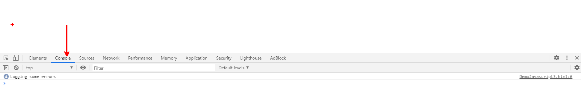

**innerHTML**

document.getElementById(“IdValue”)

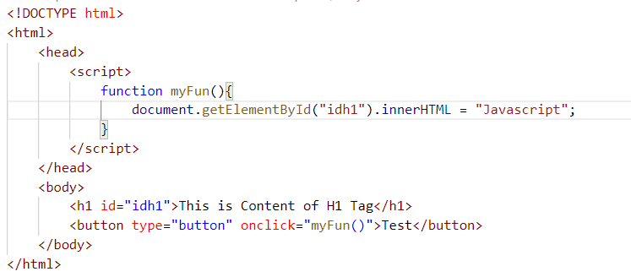

**document.getElementByID Examples**

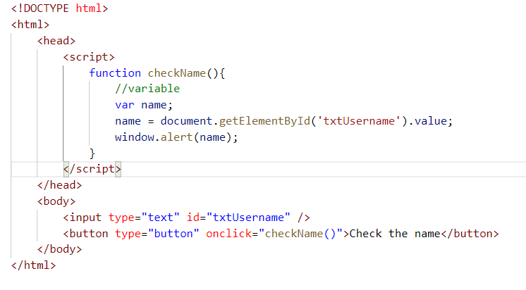

**Task 1**

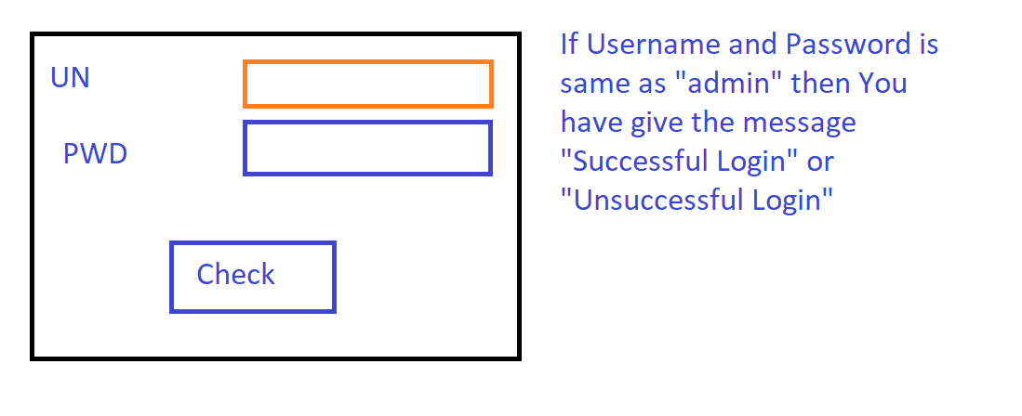

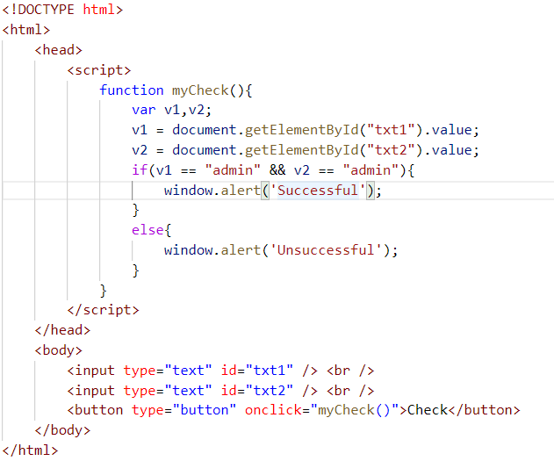

**Regular Expressions**

Goto Website “RegxPal”

Describes about the regular expressions define and test

I. Number - [0-9]

II. Small characters - [a-z]

III. Upper characters - [A-Z]

IV. No of repetitions are done with {} within this place a number

V. ^ represents - Start of Regular Expression

VI. $ represents - End of the Regular Expression

1. **Matching the 3 Digit Number**

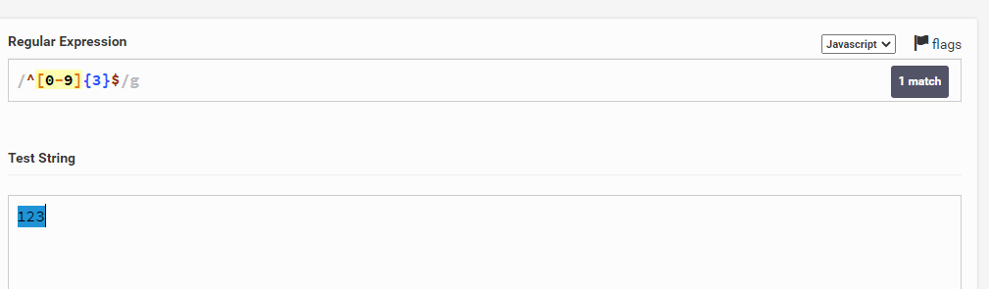

1. **Matching the Username in which minimum number of character is 6 and Maximum is 10**

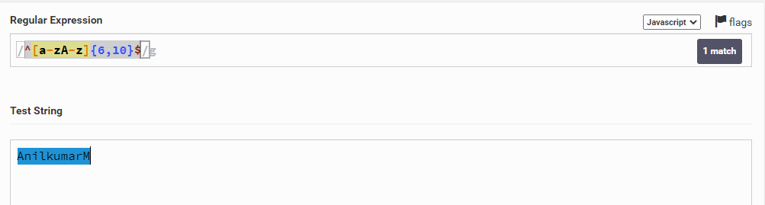

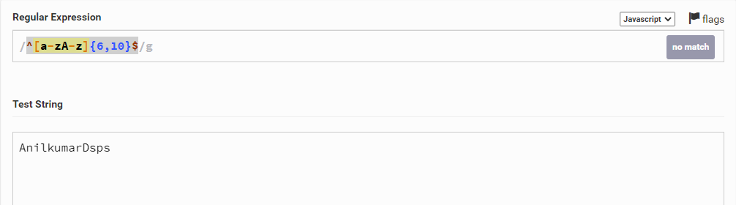

1. **Matching the Username with min - 6 and Max - 12** 
   1. **First character is always Upper case character**
   2. **Second character till last character it should accept the numbers, small characters and Upper case characters also**

